**SIGNAL PROCESSING FOR MUSIC ANALYSIS NOTES**

M. Müller, D. P. Ellis, A. Klapuri, and G. Richard, “Signal processing for music analysis,” IEEE J. Sel. Topics Signal Process., vol. 5, no. 6, pp. 1088–1110, 2011.

# PITCH AND HARMONY

Pitch – refers to a sound wave with a well-defined fundamental frequency. The signals produced by most instruments consists of a harmonic series of sinusoids. This harmonic series results in a perceived pitch in the listeners ear.

Humans perceive frequencies that fall in a ratio of 2:1 (Octave) as highly similar due to the embedded sets of harmonics.

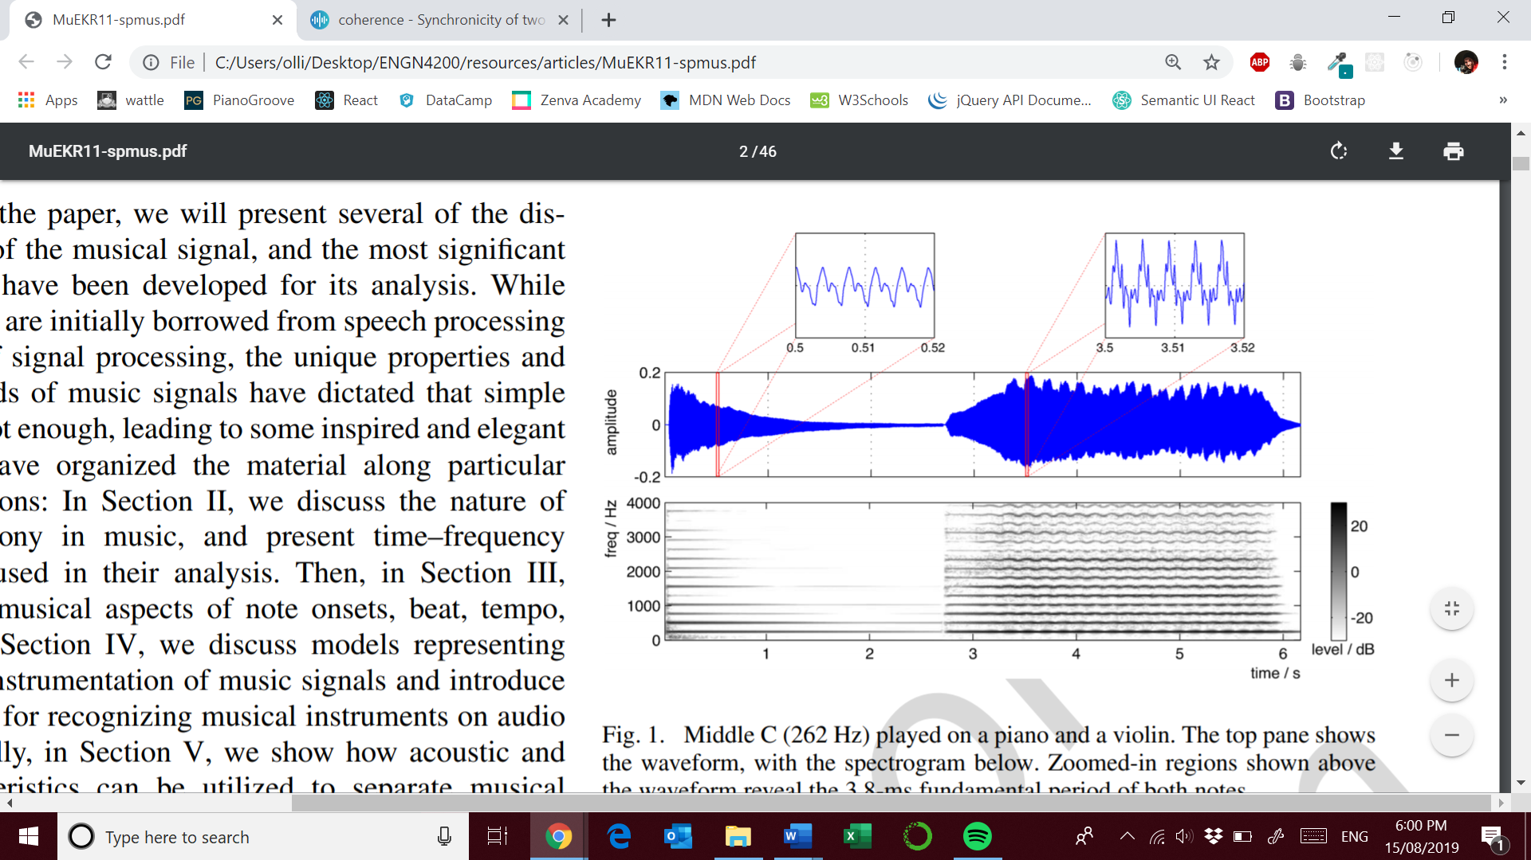

Source: M. Müller, D. P. Ellis, A. Klapuri, and G. Richard, “Signal processing for music analysis,” IEEE J. Sel. Topics Signal Process., vol. 5, no. 6, pp. 1088–1110, 2011.

Middle C played on a piano left and violin right. You can see evidence of vibrato ( slight frequency modulation ) in the spectrogram of the violin compared to the clear decay in the piano sound wave.

* Middle C: 240Hz – 262Hz ( there is a range of tunings)

Equal tempered scales allow an octave to be split into twelve equal steps on a logarithmic axis. Each note has a frequency 2^1/12 times larger ( semitone ). (2^2/12)^7 = 3/2 ie. G has a frequency that is 1.5 times larger than C

The lowest note on a piano is A0 (27.5 Hz), the highest note is C8 (4186 Hz), and middle C (262 Hz) is C4.

An octave degree is known as its chroma as seen below;

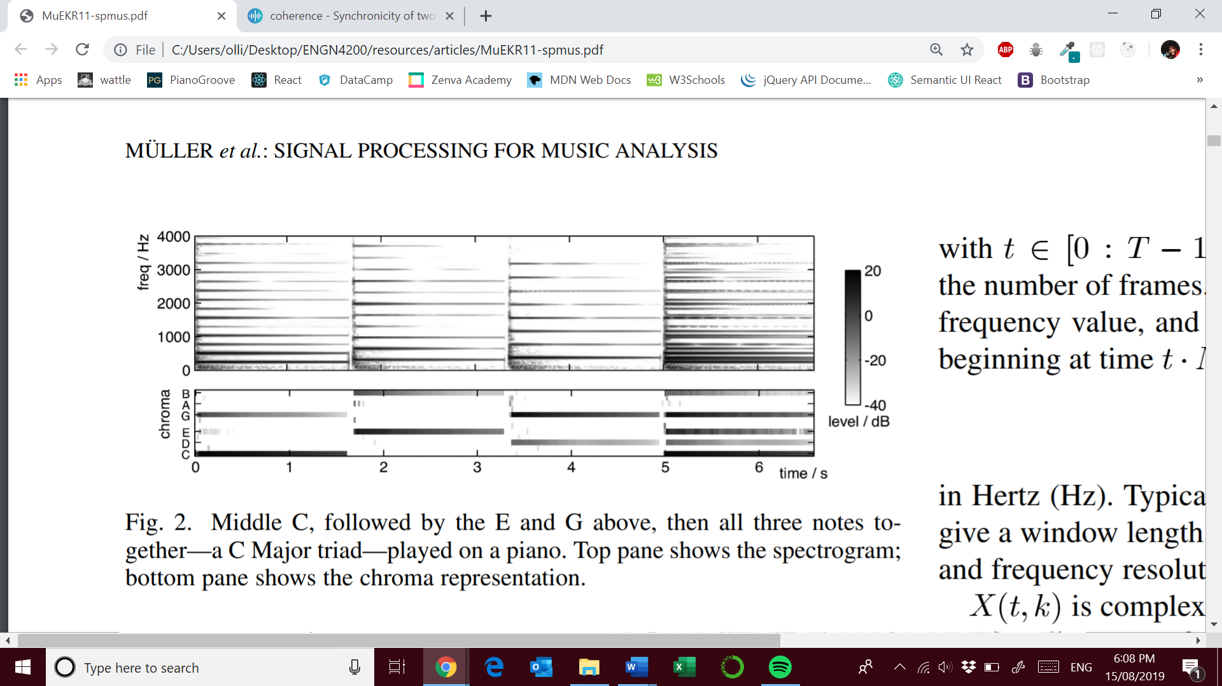

Source: M. Müller, D. P. Ellis, A. Klapuri, and G. Richard, “Signal processing for music analysis,” IEEE J. Sel. Topics Signal Process., vol. 5, no. 6, pp. 1088–1110, 2011.

They use parameters :

* Sample frequency: 44.1kHz
* Window length: 46ms -> 2028 samples

You can see that the chroma are shared in fifths. You can also see how much more complex the spectrogram is. Chroma can be thought of as a spectral template of a pitch. Consonant harmonies involve pitches with simple frequency ratios indicating many shared harmonics. The ubiquity of such consonance is a major challenge to automatic music analysis.

**TIME-FREQUENCY REPRESENTATIONS**

**USEFUL TOOLS**

**Short-Time Fourier Transform ( STFT ) – Spectrogram**

The magnitude visualisation is the spectrogram of an audio signal. We can obtain the STFT by:

* Uniform sampling of an audio signal with sampling rate of F­s
* Use of an N-point tapered window.
  + w[n] = 0.54 – 0.46cos(2*pi*n/N)
* Overlap of half a window length
  + How does this translate to hop length ?

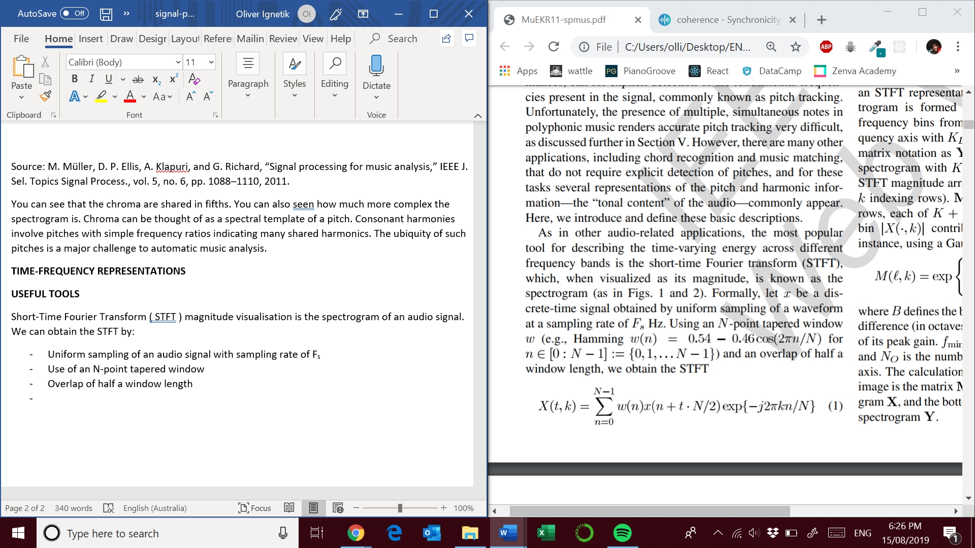

* The time resolution is : *N/Fs*
* The frequency resolution is : *Fs/N*
* Other important parameters include the number of frames *T*
* *K/2* is the last unique frequency value ( Nyquist Theorem )
* *X( t, k )* is complex-valued with the phase depending on the precise alignment of each short-time analysis window.

**Typical parameters**

* Fs = 44100 Hz
* N = 4096 samples is the window size

Magnitude only representations do not model phase interactions which can effect amplitude modulations.

**Log-Frequency Spectrogram**

Since human perception of music defines a logarithmic frequency scale it makes sense to use the same scale in music analysis.

**Constant-Q transforms** – the bandwidth of each bin varies in proportion to its centre frequency. The Q-ratio centre frequency: bandwidth remains the same. For example, if we use 12 frequency bins per octave, each bin represents a semitone of an equal tempered scale.

We can transform a STFT representation using a weighting matrix that gives each bin of the STFT a coefficient contributing to a log-frequency bin.

**Y** = **MX**,

Where M is the weighting matrix X is the original STFT magnitude array and Y is the log-frequency spectrogram. Below is an example of a gaussian filterbank;

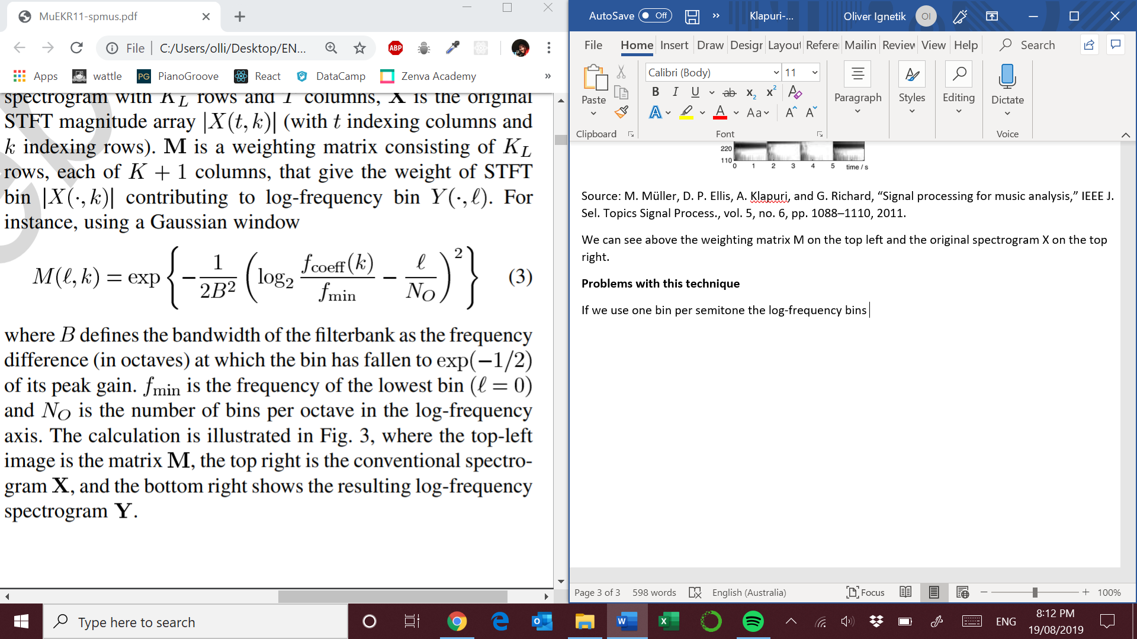

B = frequency difference ( in octaves ) at which the bin has fallen to exp(-1/2) of its peak gain.

fmin = frequency of the lowest bin ( l = 0 )

NO = number of bins per octave in the log-frequency axis

**VISUAL INTERPRETATION OF LOG FREQUENCY SPECTROGRAM**

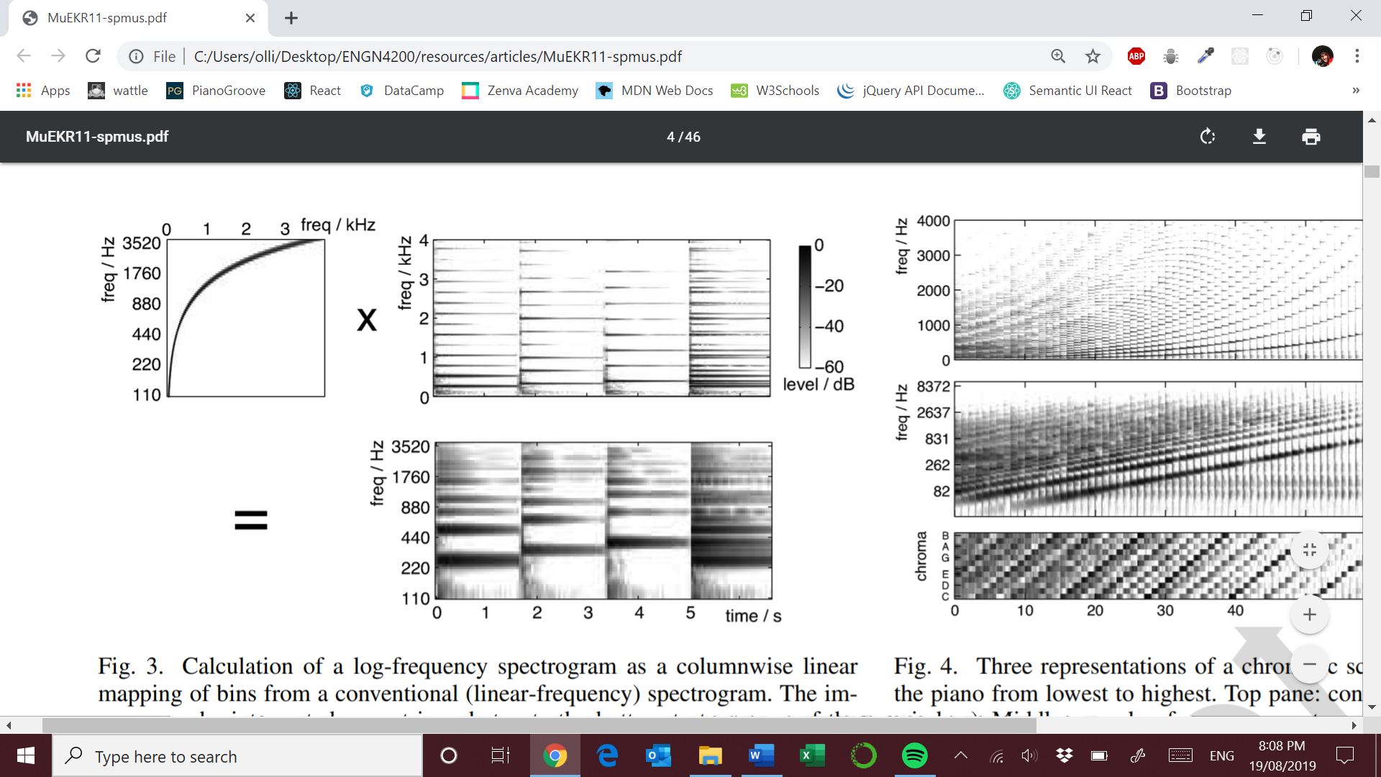

Source: M. Müller, D. P. Ellis, A. Klapuri, and G. Richard, “Signal processing for music analysis,” IEEE J. Sel. Topics Signal Process., vol. 5, no. 6, pp. 1088–1110, 2011.

We can see above the weighting matrix M on the top left and the original spectrogram X on the top right.

**KEY FEATURE NEEDED – semitone resolution**

**Problems with the log frequency mapping**

* **Blurring of the frequency bins**: If we use one bin per semitone the log-frequency bins ie. NO = 12 with fmin  = 110 Hz ( A2 ) the centres of the log-frequency bins are only 6.5Hz apart. **???**
* To have these centred on distinct STFT bins would require a window of 153ms with a sampling rate of 44100 Hz.
* **SPECTRO-TEMPORAL TRADE OFF**: We need long time windows to achieve semitone resolution at low frequencies. This is a serious problem because human perception of rhythm can discriminate changes les then 10ms. **Thus we can lose information !**
* The high frequency bins average together many STFT bins!
* The low frequency bins are only 6.5 Hz apart!

**Alternative to log frequency mapping – filter bank approach**

Construct a bank of individual bandpass filters, one per semitone, each tuned to the appropriate bandwidth with minimal temporal support.

Source: C. Schörkhuber and A. Klapuri, “Constant-Q transform toolbox for music processing,” in Proc. Sound Music Comput. Conf. (SMC), Barcelona, Pain, 2010.

**TIME-CHROMA REPRESENTATIONS**

Chord transcription is mainly focused on chroma of the notes present. Folding the octaves together is needed because octave information is of secondary importance. The chroma can be though of as a vector.

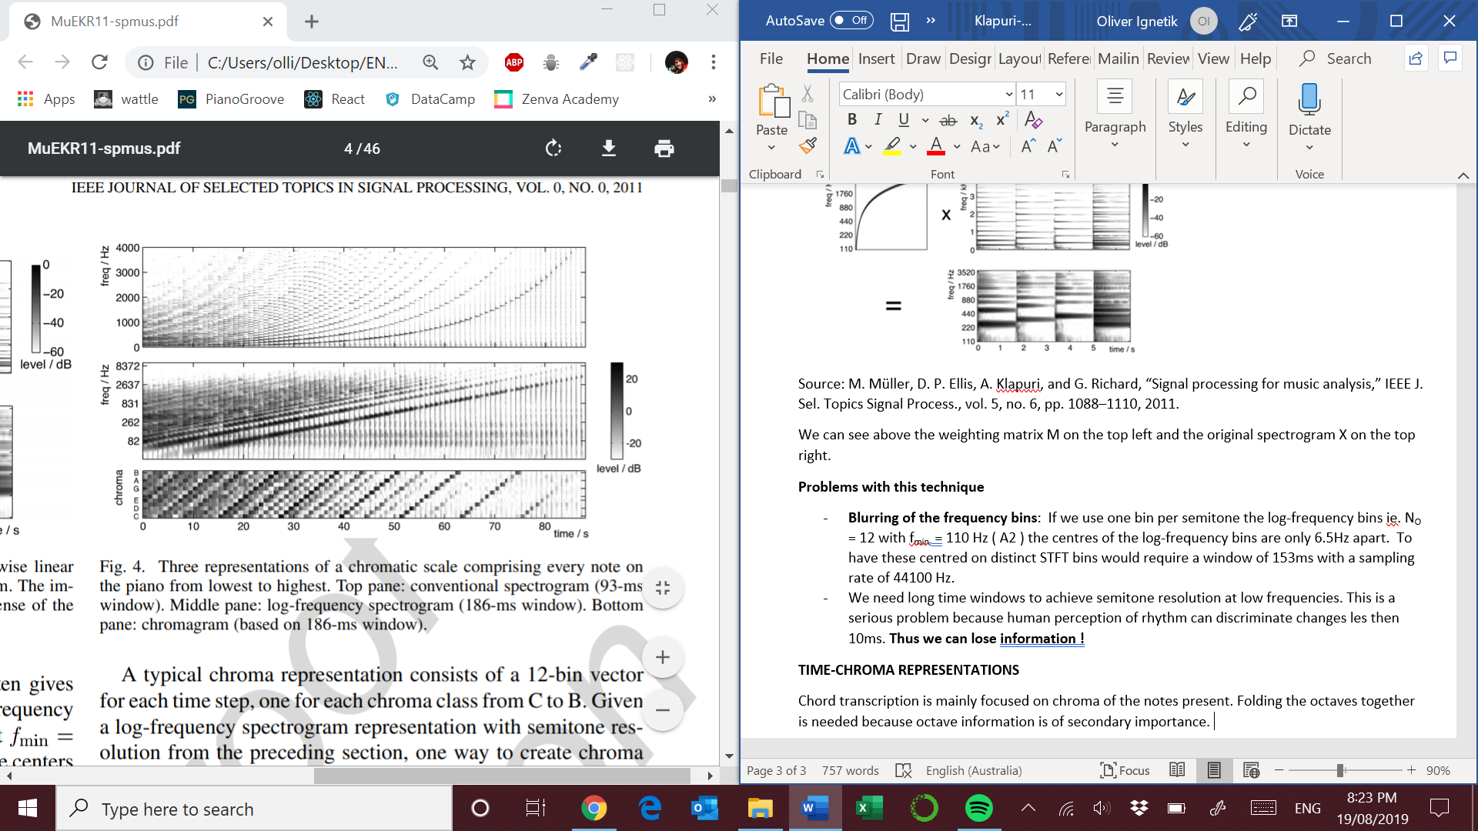

**How to construct a chromagram ?**

1. STFT with semitone resolution ie. Fres = 1.059 Hz , L = 41624 samples at Sr = 44.1kHz
2. Multiple approaches:
   1. Add together all the bins corresponding to each chroma [6]
   2. **Include energy only from strong sinusoidal components in the audio and exclude non-tonal energy such as percussion and noise**

Source: M. Müller, D. P. Ellis, A. Klapuri, and G. Richard, “Signal processing for music analysis,” IEEE J. Sel. Topics Signal Process., vol. 5, no. 6, pp. 1088–1110, 2011.

Many musical notes have the highest energy in the fundamental harmonic. With a weak fundamental the root chroma is the bin into which the greatest number of low-order harmonics fall into. Lower frequency ranges still tend to clutter the chromogram because they have energy dispersed across a large number of harmonics.

Chroma MATLAB toolbox

<http://www.ee.columbia.edu/~dpwe/resources/matlab/>

**Chroma applications**

Octave invariance is useful when investigating harmonic progressions

* Chord recognition
  + separation of tonal and percussive energy [22]
  + local normalization prior to chroma calculation [13]
* Synchronization and Alignment [6], [25]
  + Dynamic Time Warping [26], [27]
  + Use of similarity matrix to compare MIDI version and a recording
* Cover song detection
* Structure recovery and automatic segmentation
  + Identifying chorus, verse solos and other structures [39]

# TEMPO, BEAT AND RHYTHM

Tempo is the rate of the pulse of the music [46]. It corresponds to the pulse a human taps along when listening to the music [48].

It has several challenges:

* Onset detection
* Offset detection
* Temporal evolution of sound events

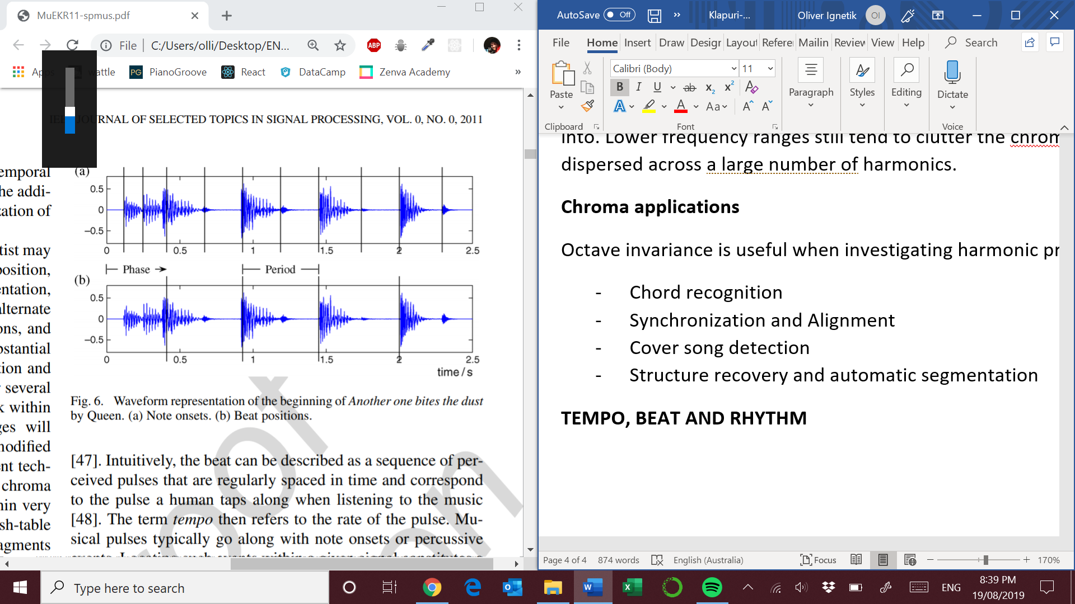

1. Note onsets
2. Beat positions

Source: M. Müller, D. P. Ellis, A. Klapuri, and G. Richard, “Signal processing for music analysis,” IEEE J. Sel. Topics Signal Process., vol. 5, no. 6, pp. 1088–1110, 2011.

**Onset detection**

The general idea is to capture sudden changes in a music signal. By doing so you will obtain a *Novelty Curve* [49], [50] (give an **overview** of this topic)

Non-percussive instruments have a number of challenges such as :

* Soft onset ( flutes etc. )
* Blurred note transitions ( sliding up to notes )
* Masking effects

Some methods for computing refined novelty curves (pg. 6)

* Spectral content analysis [49] , [51]
* Pitch analysis [51], [52]
* Harmony and phase [53], [54], [49], [55]
* Instrument specific [51], [56]
* Resolution of masking effects with band wise analysis using detection functions to extract transients occurring in certain frequency regions of the signal [57], [58]. For example when a sudden energy increase occurs, one can often observe an accompanying broadband noise burst in the signal’s spectrum. This effect is mostly masked by the signals energy in lower frequency regions, but is detectable in higher frequency ranges.

**Spectral Flux**

Spectral flux is a widely used approach to detect onsets of notes in the frequency domain [49], [60].

See references [49], [60] for an **overview** of spectral flux techniques

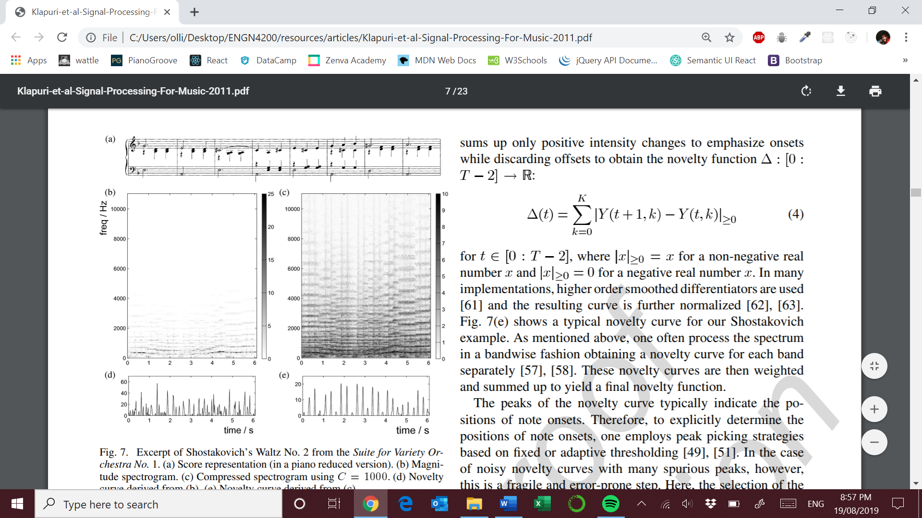

1. Score representation
2. Magnitude spectrogram
3. Compressed spectrogram
4. Novelty curves b)
5. Novelty curve for c)

You can see in this novelty curve that there are blurred onsets in the first bar as the non-percussive instruments are playing the notes softly

Source: M. Müller, D. P. Ellis, A. Klapuri, and G. Richard, “Signal processing for music analysis,” IEEE J. Sel. Topics Signal Process., vol. 5, no. 6, pp. 1088–1110, 2011.

**Spectral based approach for computing novelty curves**

1. STFT of music recording
2. Binning strategies to switch over to a logarithmically spaced frequency axis [57], [58]
3. Logarithmic compression – apply a logarithm to the magnitude spectrogram of the signal (corresponds to c) above) [57]. Balancing out the dynamic range of the signal, by amplifying low intensity values in the high frequency spectrum.
4. Compute the discrete derivative of the compressed spectrum Y. This can be done in a band wise fashion and the emphasis is placed on onsets. [57], [58], [61], [62], [63]

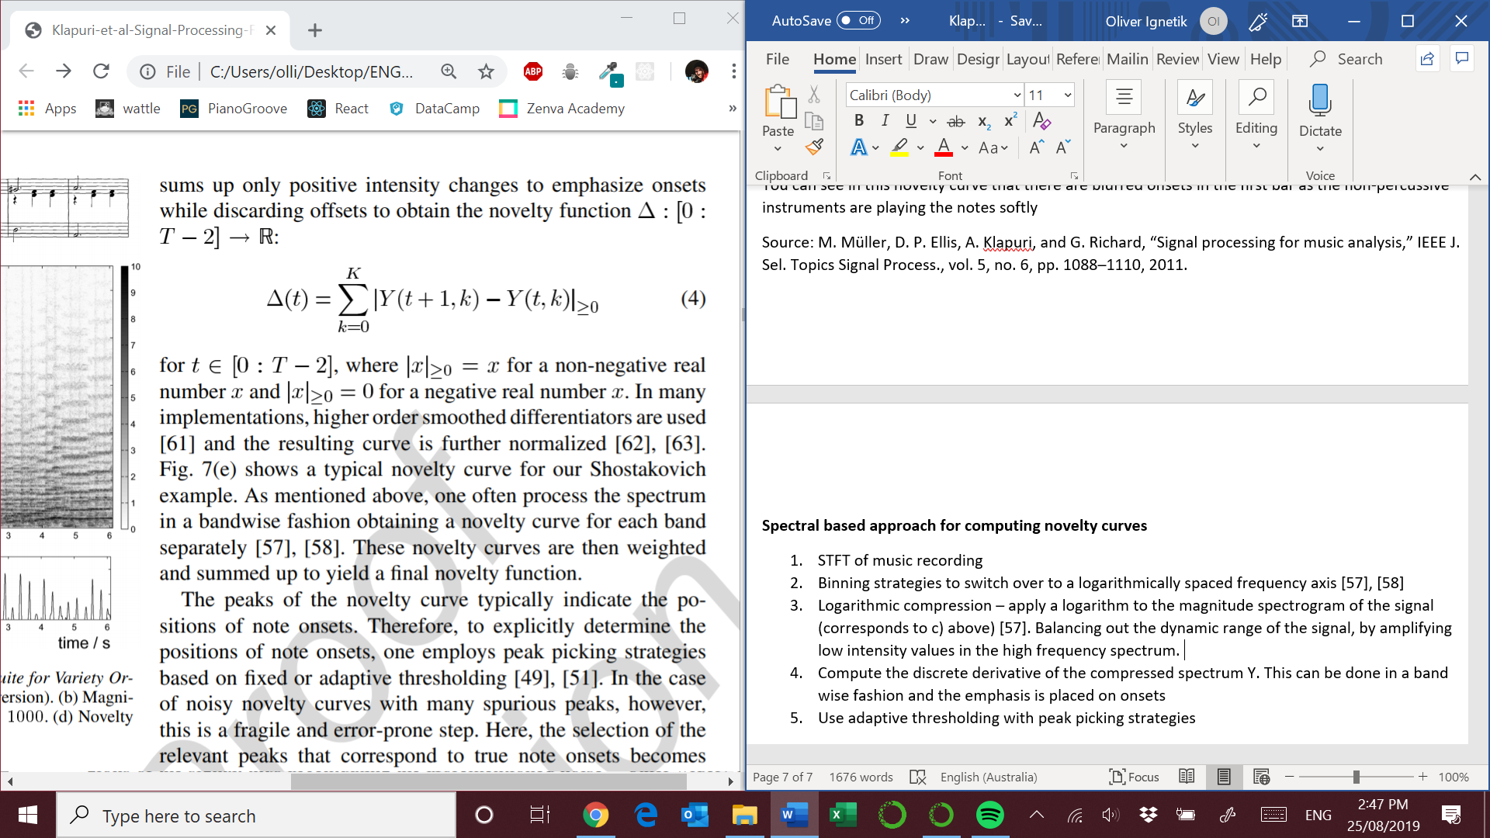

1. Use adaptive thresholding with peak picking strategies [49], [51]. This can be very difficult when downbeats are played softly by non-percussive instruments with soft onsets.

**Periodicity and Tempo Estimation**

Novelty curves can be used to detect reoccurring quasi-periodic patterns. There are a number of methods used :

* Autocorrelation method : compare a novelty curve with time-shifted copies [65]-[68]
* Bank of filter resonators
* STFT novelty curve representation

See reference [64] for an **overview** of various approaches

**Beat spectrogram [71]**, tempogram [69] and rhythmogram [70] are representations of such approaches.

Harmonics in tempo – where tempo is an integer multiple of the fundamental tempo

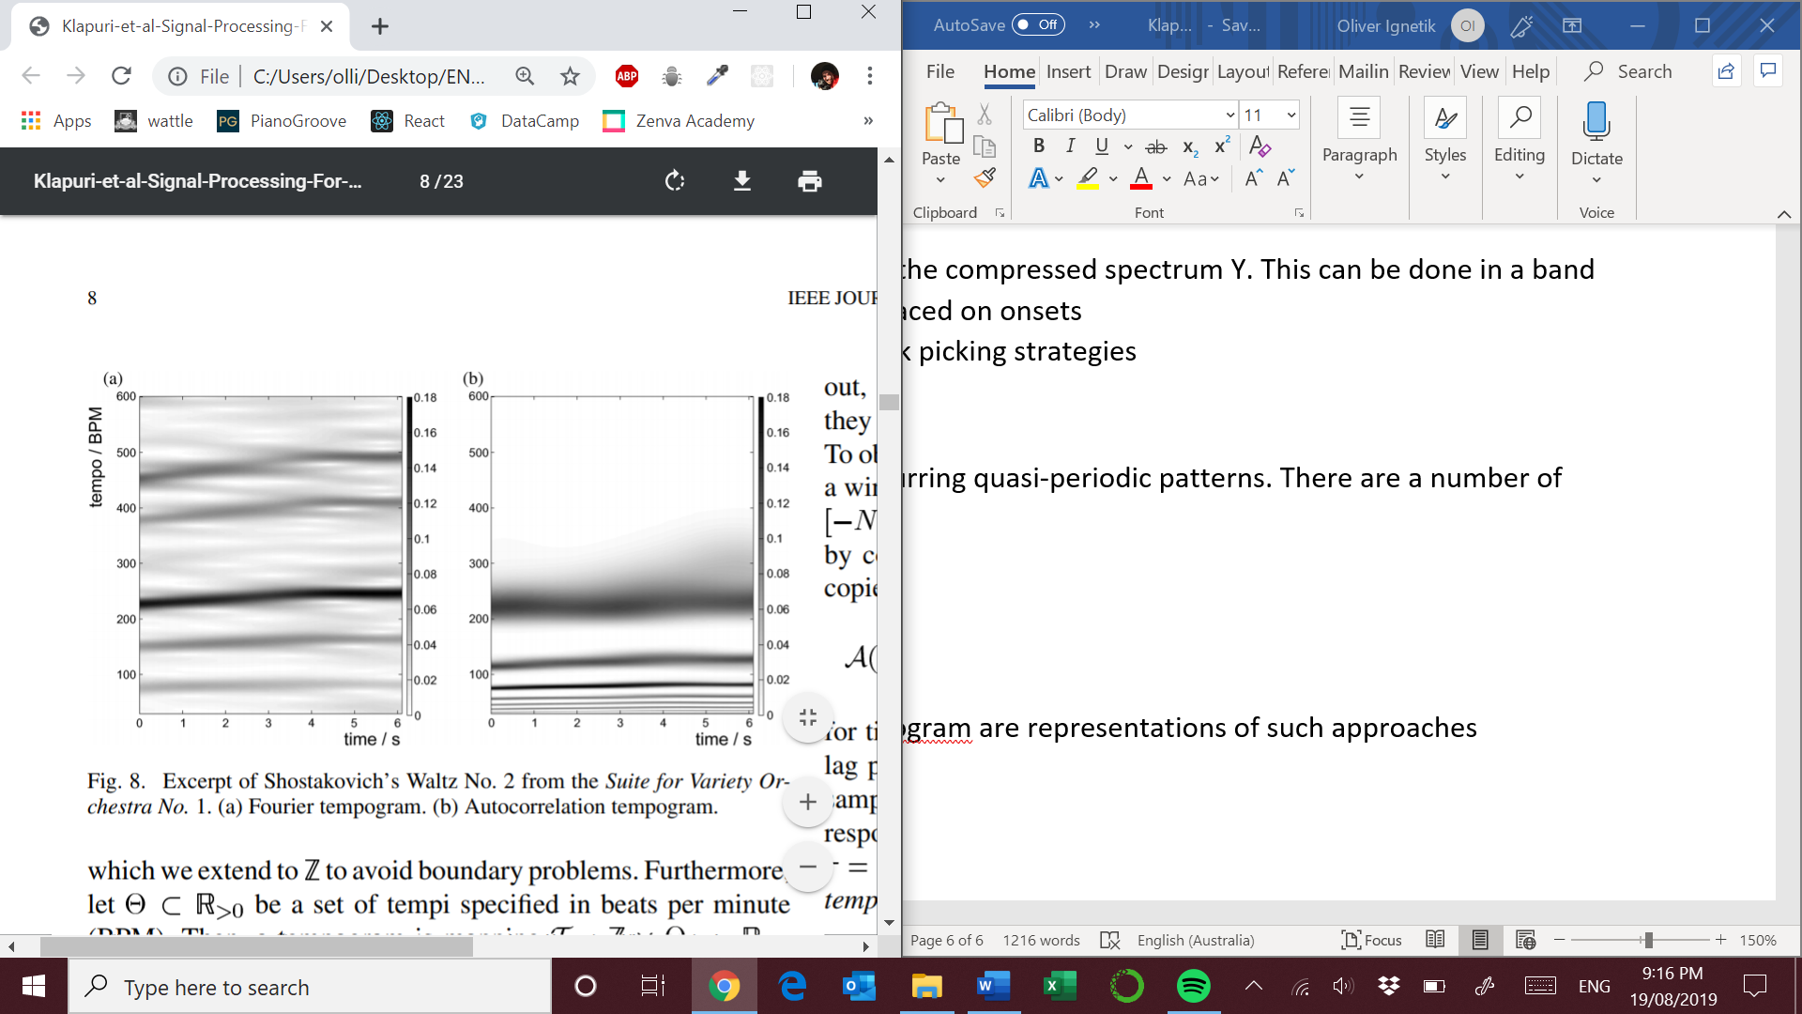

Source: M. Müller, D. P. Ellis, A. Klapuri, and G. Richard, “Signal processing for music analysis,” IEEE J. Sel. Topics Signal Process., vol. 5, no. 6, pp. 1088–1110, 2011.

1. Fourier tempogram [62], [63], [67] suppress subharmonics
2. Autocorrelation tempogram [66], [73], [74] suppress harmonics

The above graphs indicate the most prominent temp over such time periods. Tempo ambiguities complicate matters in the same way harmonics in pitch recognition does with aliasing. **Cyclic tempograms** can be constructed that overcome this [72], [73]. They are analogous to the relationship between chroma and pitch.

The two methods complement each other quite well because the Autocorrelation tempogram can highlight tempo on a measure level whereas the Fourier tempogram can highlight tempo on a beat level.

Seems as if local tempo estimation is an ill posed problem. However, there are a number of approaches:

* Framewise maximum of the tempogram
* Global optimization techniques based on dynamic programming which smooth trajectories [61], [67]

**BEAT TRACKING**

Most humans when listening to a piece of music can usually tap out the beat without difficulty. However, significant tempo changes in pieces pose significant problems in this task [75].

A tatum / temporal atom refers to the fastest repetition rate of musically meaningful accents occurring in the signal [79]. In [62] and [63], a robust mid level representation is used which captures predominant local pulse even with tempo changes. [66] explains technique making use of neighbourhood functions and novelty curves as parameters for the algorithm which produces a beat sequence B = [b1,b2,b3…,bL]

Beat tracking works well in music with a steady pulse like pop and rock music. But for music where there is more expression like classical or jazz the local periodicity model assumption is violated. These genres reveal the limits of purely onset-oriented tempo tracking [63], [82].

**HIGHER LEVEL RYTHMIC STRUCTURES – TIME SIGNATURE**

The extraction of onset, beat and tempo are inputs for calculating rhythm and meter [46], [48]. Generally, rhythm refers to temporal patterning of strong and weak stimuli [83]. Repeating patterns of accents form pulse groups which determine the meter of a piece of music. The frequency of pulse groups in each bar can be averaged over the entire piece to quote a particular rhythmic pattern for the entire piece [84], [85] Another way is to use histograms and inter-onset-intervals to derive hypotheses for beat period, tempo and meter [75], [76]

# TIMBRE AND INSTRUMENTATION

The attribute of auditory sensation in terms of which a listener can judge two sounds similarly presented, with the same pitch and loudness and still tell them apart. Polyphonic timbre refers to the overall mixture of a music signal [89], [90].

Useful applications:

* Genre identification [93]
* Emotional recognition [94]
* Tagging with semantic descriptors [95]

**Perceptual Dimensions of Timbre**

Schouten [96] describes timbre as having the following parameters:

1. Range between tonal and noise-like character
2. Spectral envelope
3. Time envelope
4. Changes of spectral envelope and fundamental frequency
5. Attack period and sustain period differentiation

**Spectral centroids ( centre of mass of the spectral envelope) and attack time are major contributors**

**Polyphonic timbre dimensional analysis is unexplored**

* Cogan [99] carried out musicological studies using the spectrograms of diverse music signals and proposed 13 parameters for polyphonic music.
* Kendall and Carterette [100] studied perceptual dimensions of wind instrument timbres using MDS

**Time-Varying Spectral Envelope**

In signal processing applications timbre is described using a parametric model of the time-varying spectral envelope of sounds.

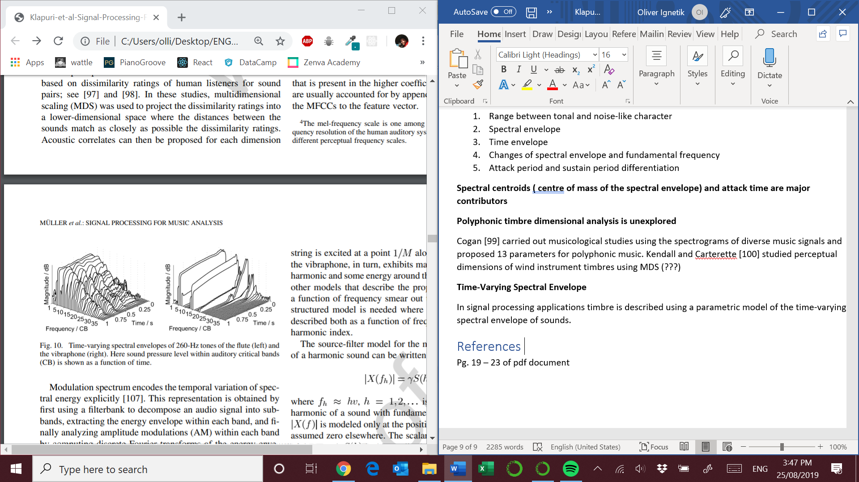

Source: M. Müller, D. P. Ellis, A. Klapuri, and G. Richard, “Signal processing for music analysis,” IEEE J. Sel. Topics Signal Process., vol. 5, no. 6, pp. 1088–1110, 2011.

The figure above gives strong support for the features uncovered in [100] and [96].

Mel-frequency cepstral coefficients (MFCCs) are the best way to describe the spectral envelope within an individual analysis frame. See [106] for other frequency scales.

**How to calculate them ?**

1. Simulating a bank of bandpass filters uniformly spaced on the Mel-frequency scale
2. Calculating the log-power of the signal within each band
3. Apply a discrete cosine transform to the vector of log-powers
4. Retain the lowest 10-15 coefficients

Modulation spectrum encodes the temporal variation of spectral energy explicitly [107]. Spectro-temporal modulations are extremely useful in complex music signals [90], [108]

**Source-filter model of sound production**

Many musical instruments can be viewed as a coupling of a vibrating object, such as a guitar string, and the resonance structure of the rest of the instrument body which colours the sound.

**Applications**

Regularities in the source excitation are best described in terms of a harmonic index. For example, a clarinet is characterized by the odd harmonics being stronger than the even harmonics. Models use both the harmonic index and the frequency.

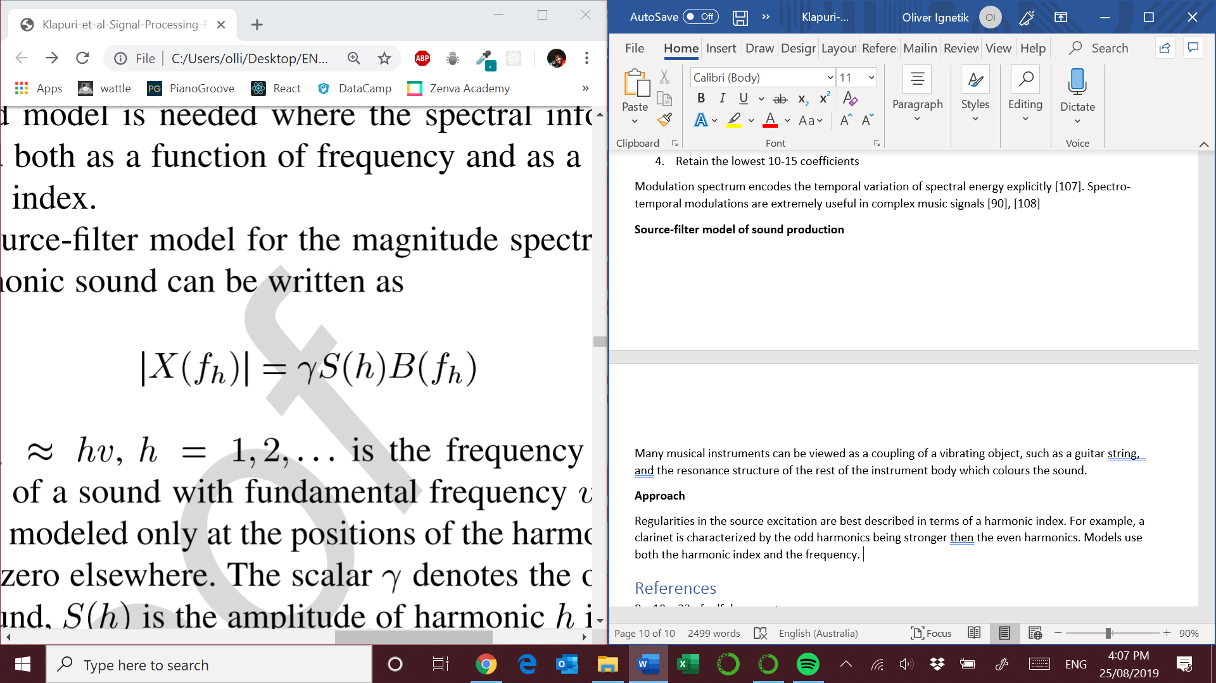

Where fh = hv, h = harmonic index and v = fundamental frequency.

S(h) is the amplitude in the spectrum of the vibrating source and B(fh) is the response of the instrument body.

This model is very robust and can be used for melody separation [114] and instrument recognition in mixture signals [115]

**Recognition of Musical Instruments in Isolation**

Systems developed for this purpose typically employ a supervised classification approach. The process is usually as followed:

1. Acoustic features are extracted in each time frame. [119] explains feature selection methods. Also see [101], [122], [125] for a comprehensive list of acoustic features
2. Training data representing each instrument class is used to learn a model
3. Classify unseen samples

Some of the methods used :

* K-nearest neighbours, SVM, decision trees
* Gaussian mixture models, HMM [127], [128]
* Linear discriminant analysis
* NNs

See references [119]-[122] for a review of these systems.

**Instrument Recognition in Polyphonic Mixtures**

This topic is closely related to sound source separation. How can we develop a time-frequency mask that indicates the spectral components that belong to each instrument?

Some of the methods used include:

* **Extraction of acoustic features** directly from the mixture signal [129]. Little and Pardo found that training the models on mixture sounds performed better than using training data of isolated instruments. [124] looked at combination of instruments. Kiahara et al [133] obtained feature weightings where the largest weights were given to features that were least effected by the overlapping partials of co-occurring sounds.
* **Sound source separation** followed by classification of each separated signal. [115] used multiple-F0 estimation to produce candidate F0s at each time instant and then used a variation of NMF to assign sounds to their respective instruments. See for [123], [134]-[136] for more approaches
* **Signal model-based probabilistic inference.** Vincent and Rodet [138] viewed instrument recognition as a parameter estimation problem for a given signal model. They represented the short-term log-power spectrum of polyphonic music as a weighted nonlinear combination of typical note spectra plus noise.
* Dictionary based methods [139], [140], [110]

# Polyphony and Musical Voices

There are two main strategies for dealing with this type of mixture:

1. Process the signal globally
2. Perform source separation of the mixture into sources

**Source Separation**

This task involves separating a mixture into individual tracks for each instrument. See [141], [142] for a great **overview.**

Several systems rely on a simplifying paradigm in this task that does not extract the full bandwidth source signals.

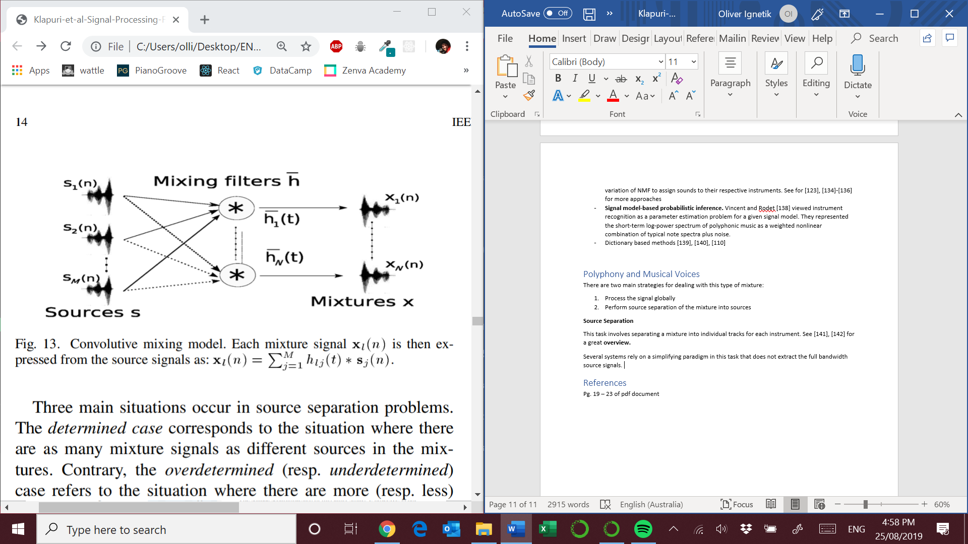

Source: M. Müller, D. P. Ellis, A. Klapuri, and G. Richard, “Signal processing for music analysis,” IEEE J. Sel. Topics Signal Process., vol. 5, no. 6, pp. 1088–1110, 2011.

Estimating the mixing matrix and source signals are the goal in this task and there are a wide range of approaches based on ICA, sparse decompositions and clustering approaches [141]

Three main situations occur in source separation problems :

1. Determined – equal mixture signals and sources
2. Overdetermined – more mixtures then sources
3. Undetermined – more sources then mixtures – is the most difficult [145], [144]

In the case of the undetermined problem there are many approaches:

* Heuristic methods
* Minimization criteria
* Time Frequency masking approaches. Wiener Filtering is a popular approach.

Prior information can be used to improve the models performance such as :

* Timbre models [146]
* Harmonicity [147]
* Temporal continuity and sparsity continuity [148]

This domain is quite developed and evaluation metrics are now well established [150].

**From Monopitch to Multipitch Estimation**

For an **overview** of current works refer to [161]-[163]

There are a number of methods used in this sub-topic that can be separated into three classes:

1. Frequency domain approaches – investigating harmonics of signals. The fundamental frequency is estimated by selecting the highest frequency that generates a spectral comb best explaining the spectral content of the signal [153]-[155]
2. Time domain approaches – Autocorrelation, average magnitude difference or kernel based approaches applied to the time signal. One can directly estimate the period on the basis of the signal’s waveform by searching the smallest time-shift for which the waveform and the its time-shifted version match.
3. Mixed domain approaches [159], [160]

To name a few approaches in the spectral domain:

1. Global strategy of jointly estimating all fundamental frequencies. Parametric methods [164], [165]. Machine learning [167], [168]
2. Source separation strategy – NMF based approaches [147], [148], [170] Iterative approaches based on this approach seem to perform well in MIREX.

Most methods exploit musical knowledge in one way or another:

* Timbre information as spectral templates [172]
* Spectral smoothness models picking more realistic notes [171]
* Constraints based on evolution of partials amplitudes [165]
* Note evolution models using HMM [173], [174]
* Knowledge of auditory perception [159], [175]

**Why does a musician have no problem analysing a chord containing two notes one octave apart ?**

**Main melody or Singing Voice Extraction**

Lots of commercial applications possible in this topic:

* Karaoke [177]
* Query-by-humming [178]
* Lead sheet generation [179]

There are few studies that address the full problem leading to a musical score of the melody line, which integrates note segmentation [174], [179].

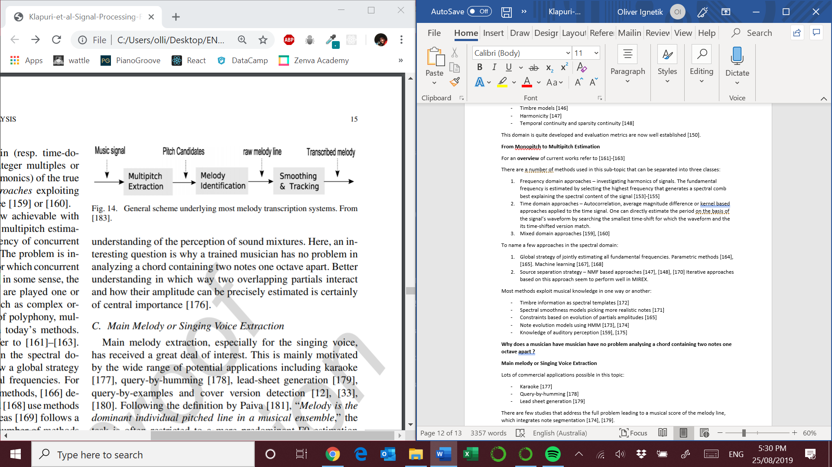

Source: M. Müller, D. P. Ellis, A. Klapuri, and G. Richard, “Signal processing for music analysis,” IEEE J. Sel. Topics Signal Process., vol. 5, no. 6, pp. 1088–1110, 2011.

HMMs, probabilistic models and dynamic programming are used to identify pitch candidates. It seems that some of the most promising results are based around statistical systems.

One statiscal approach [114], [186] used gaussians to model the **melody voice v(n)** and the **background m(n).** The STFT of the mixture X(n,k) = V(n,k) + M(n,k).

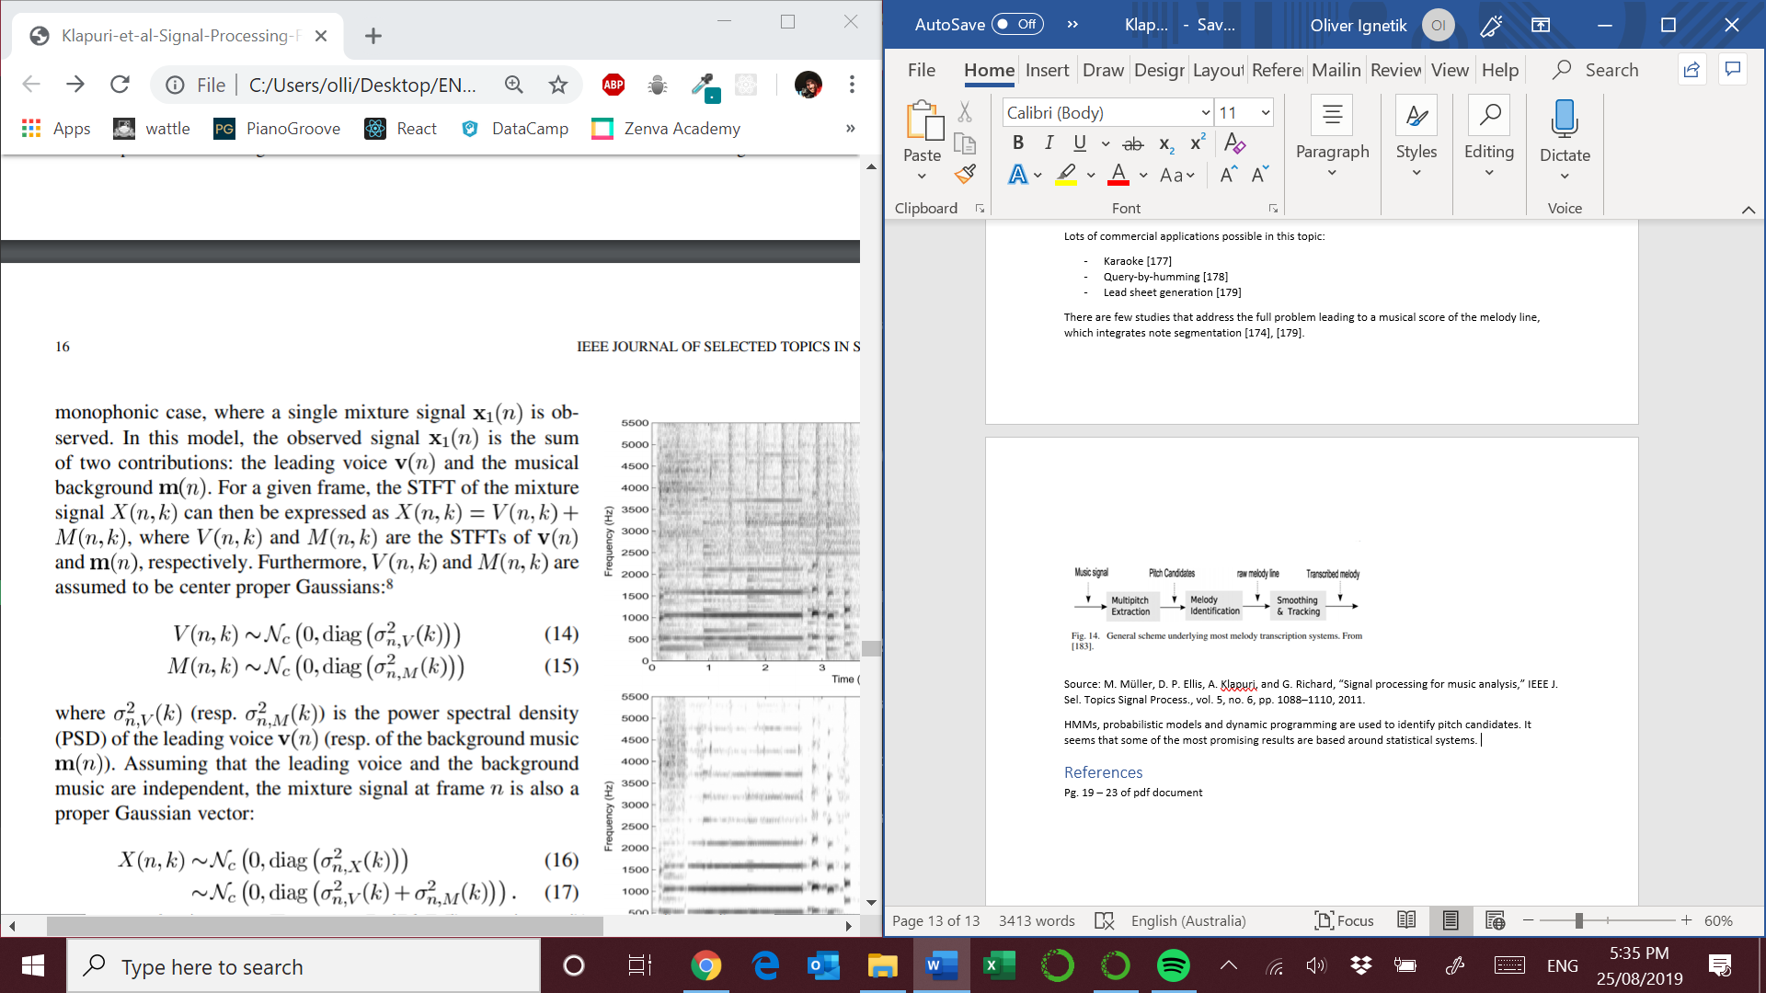

Source: M. Müller, D. P. Ellis, A. Klapuri, and G. Richard, “Signal processing for music analysis,” IEEE J. Sel. Topics Signal Process., vol. 5, no. 6, pp. 1088–1110, 2011.

To extract the main melody line, one needs to estimate the variance of both PSDs. This can be done by expressing the PSDs as Gaussian Mixture Models learned on dedicated databases [145].

In [114] the approach is entirely unsupervised with no learning step. The estimation of the various model parameters is then conducted by iterative approaches based on NMF techniques. Once the PDSs are obtained a Wiener filter is used for each frame as in [12]

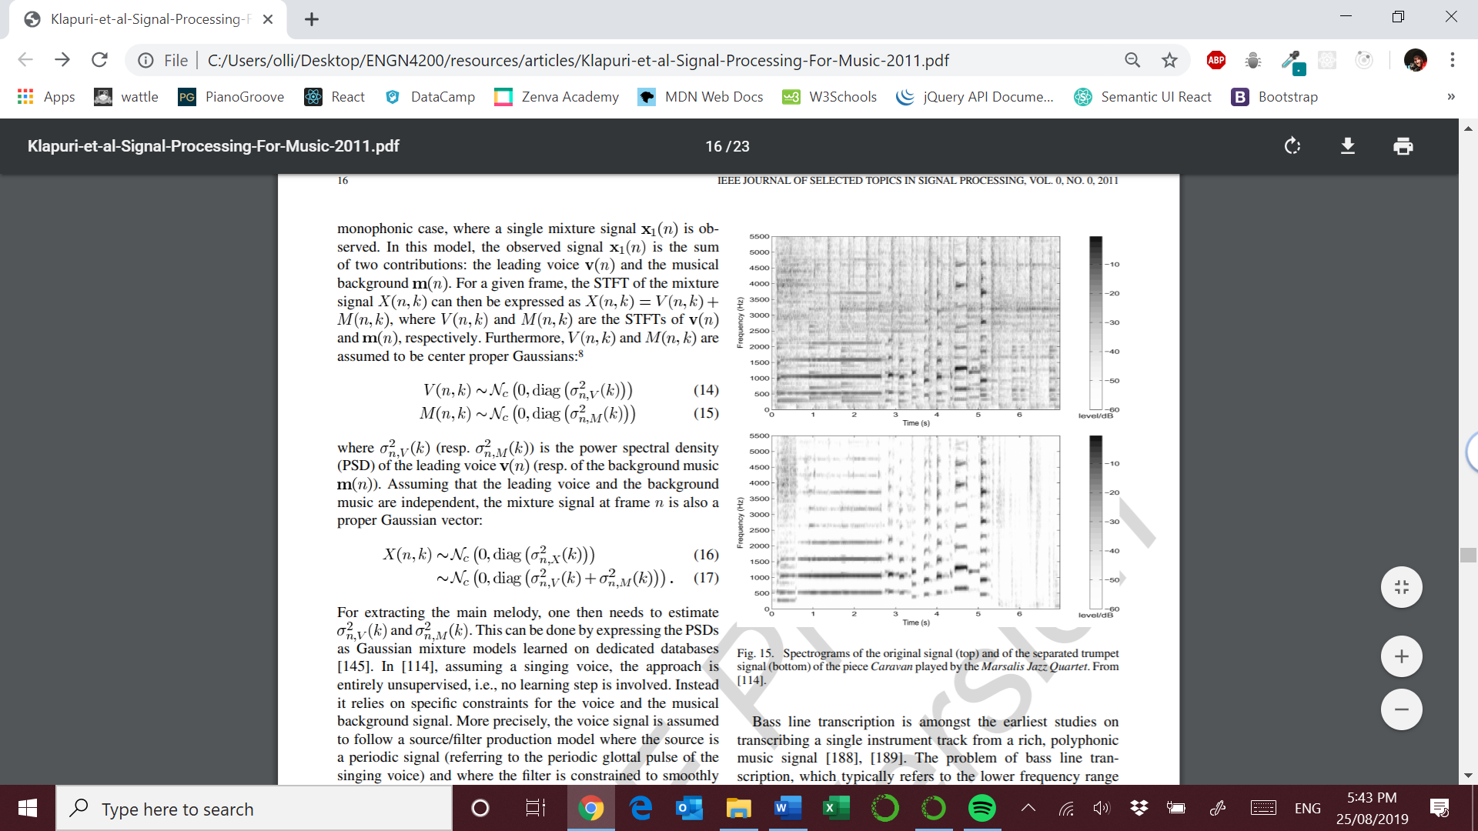

Source: M. Müller, D. P. Ellis, A. Klapuri, and G. Richard, “Signal processing for music analysis,” IEEE J. Sel. Topics Signal Process., vol. 5, no. 6, pp. 1088–1110, 2011.

**Bass Line Extraction**

The bass line plays an important role in several music styles. It has a number of useful applications including: chord extraction , downbeat estimation, music genre or mood classification [187].

One system proposed in [190] is based on two frame-based feature extractors. They are:

1. A MPE estimator that provides salience values for four F0 estimates
2. Accent estimator that measures probabilities of onsets

Specifics of model

* Bass notes are modelled using a three-state left-right HMM while rest notes are represented by a four-component GMM model (equivalent to a single state HMM).
* Musicological model that controls transition probabilities depending on the musical key and proceeding notes.
* Viterbi decoding is performed to obtain the most probable path through the models

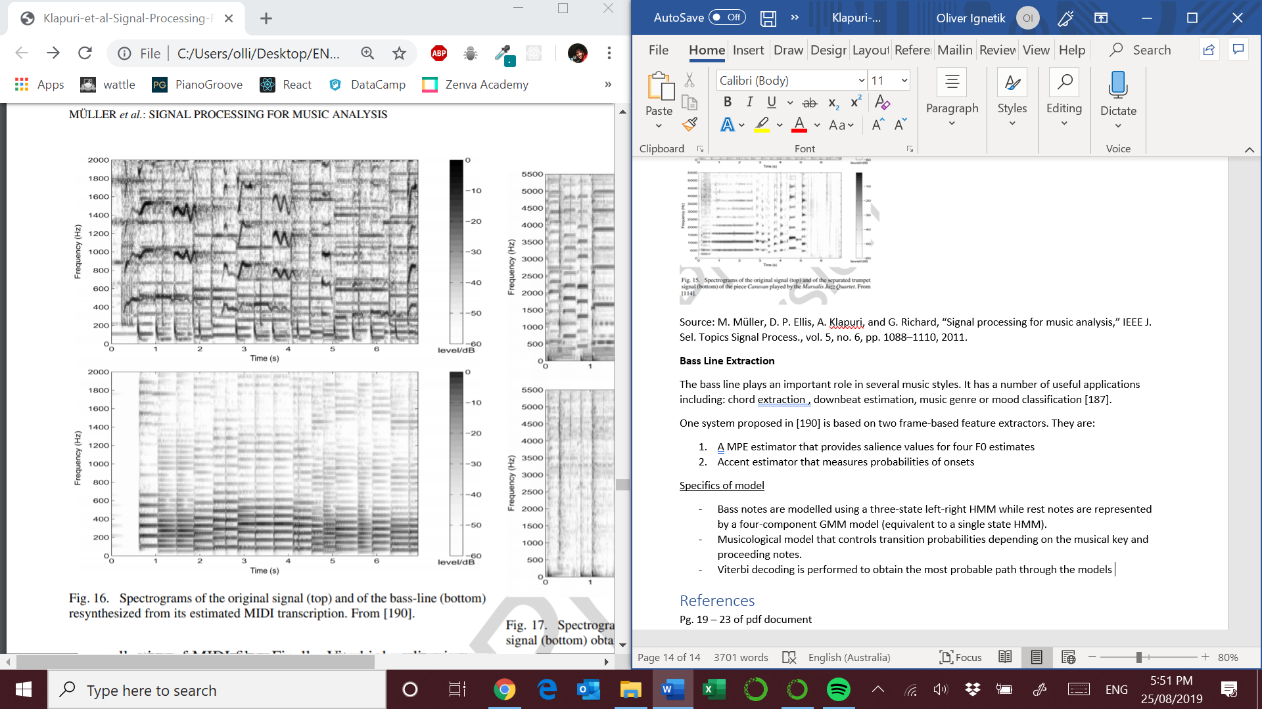

Source: M. Müller, D. P. Ellis, A. Klapuri, and G. Richard, “Signal processing for music analysis,” IEEE J. Sel. Topics Signal Process., vol. 5, no. 6, pp. 1088–1110, 2011.

# Conclusion and future directions

* Decomposition of a music signal into the main melody and accompaniment. [180]
* Decomposition into percussive and harmonic components. [22], [105], [61]
* Sound source separation algorithms in complex orchestral music
* Generate alternatives to the lack of ground truths. The entire field in chord recognition is using a list of 200 tracks with ground truths [23]. There are multiple versions of each piece of music including: lyrics, MIDIs, partial mixes from the original studio tracks.
* Build systems that are genre specific through the use of context-adaptation layers and feature tuning. One could use a classification model to determine the best model for the genre of interest.
* Better understanding of auditory perception [176], [215]
* Concurrent use of different musical elements to better inform other model features [20], [54], [75], [216], [217]

# References

Pg. 19 – 23 of pdf document